HONG KONG INSTITUTE OF VOCATIONAL EDUCATION
Laboratory 3a: Instance and Static Members

TASK:

1. Estimate the output of the following code segment without using computer. Verify your result by using computer after you have finish it.

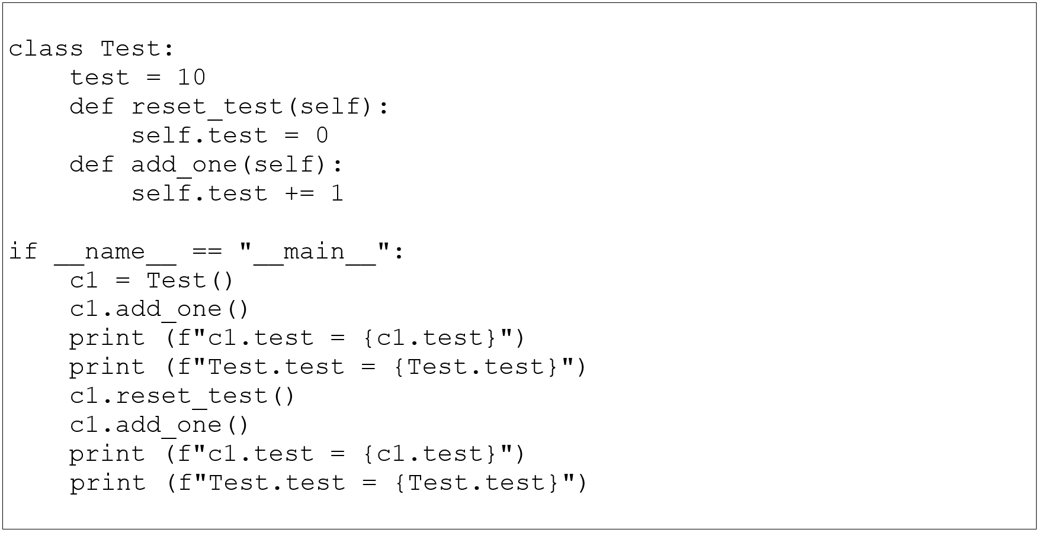

Estimated output:
c1.test = 11
Test.test = 10
c1.test = 1
Test.test = 10

2. (a) Create a class Rectangle that has:
Rectangle
__length : float
__width : float
__no_of_rectangle : int

__init__ (self, length, width)
find_area (self) : float
find_perimeter (self) : float
find_number_of_rectangle () : int
Attributes:
length – to store the length of rectangle
width – to store the width of rectangle
no_of_rectangle – to store the total number
of rectangle created by
rectangle class
Methods:
__init__ – initialize the length and wdith
attributes
adds no_of_rectangle by one to count the total numbers of rectangles created
find_area – return the area of rectangle object in float format
find_perimeter – return the perimeter of rectangle object in float format
find_number_of_rectangle – return the no_of_rectangle static variable in integer format
Answer:

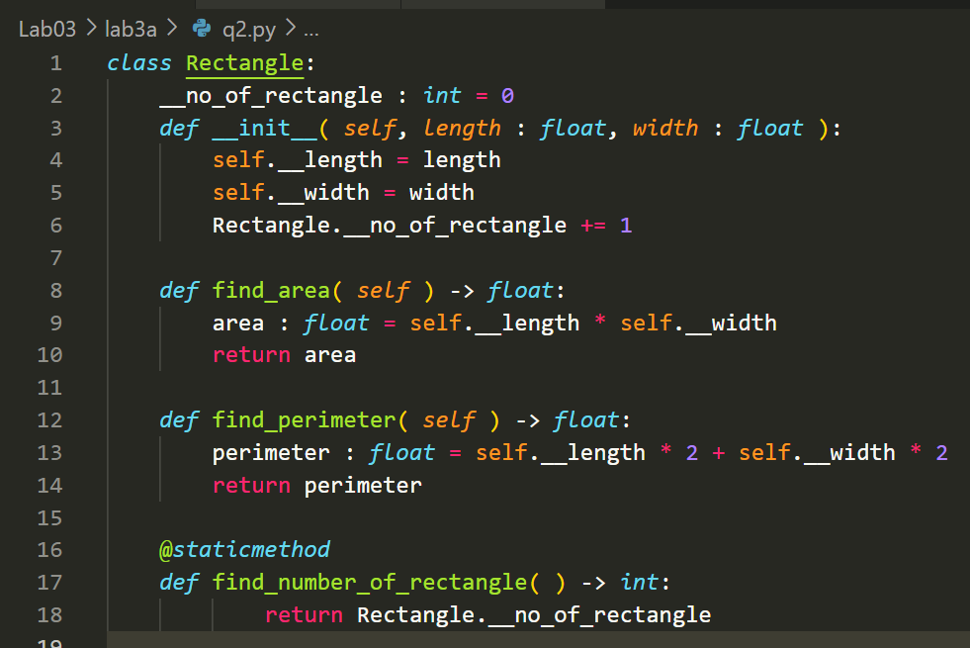
(b) Write the supplier class and client / driver program that will do the following:
(i) Create a rectangle object r1 with length 1 and width 1.
(ii) Create a rectangle object r2 with length 2 and width 3.
(iii) Create a rectangle object r3 with length 1 and width 3.
(iv) Print the area and perimeter of the three rectangle objects as shown in the sample output.
(v) Print the total number of rectangles created counted by the static variable __no_of_rectangle.

Sample Output:
r1: area=1, perimeter=4
r2: area=6, perimeter=10
r3: area=3, perimeter=8
Totally there are 3 rectangle(s) created
Answer:

